Characterization of salivary calculi

P. Nolasco*,**, A. J. Anjos***, A. Almeida***,J. M. Aquino Marques***, F. Cabrita****, E. Carreira da Costa****, J. Rocha Mendes*****, A. P. Alves de Matos******,*******and P. A. Carvalho*,**

* ICEMS, Instituto de Ciência e Engenharia de Materiais e Superfícies, Instituto Superior Técnico, Av. Rovisco Pais, 1049-001 Lisboa, Portugal

** Departamento de Bioengenharia, Instituto Superior Técnico, Universidade Técnica de Lisboa, Av. Rovisco Pais, 1049-001 Lisboa, Portugal

*** Faculdade de Medicina Dentária, Universidade de Lisboa, Cidade Universitária, 1649-003 Lisboa, Portugal

**** Serviço de Cirurgia Maxillo-Facial, Centro Hospitalar de Lisboa Central, R. José António Serrano 1150-199 Lisboa, Portugal

***** Serviço de Urologia, Hospital Curry Cabral, R. da Beneficência, 1069-166 Lisboa, Portugal

****** CESAM, Centro de Estudos do Ambiente e do Mar – Polo de Lisboa. Faculdade de Ciências da Universidade de Lisboa, Campo Grande, 1149-016 Lisboa, Portugal

******* Departamento de Anatomia Patológica, Hospital Curry Cabral, R. da Beneficência,1069-166 Lisboa, Portugal

Calculi in salivary glands and ducts (sialoliths) can be found in about 1% of the general population [[1],[2]]. Typically sialolithiasis causes long-term obstruction of salivary secretions, leading to atrophy of the gland with concomitant ceasing of the secretory function and ultimately fibrosis [[3]]. Although some theories have been put forward regarding the etiology and pathogenesis of salivary calculi, the exact nucleation and growth mechanisms remain elusive. An exhaustive characterization of salivary calculi and systematic evaluation of the existing etiologic theories is therefore required [[4],[5]].

Structural and chemical characterization of siaoliths has been carried out by scanning electron microscopy (SEM) and transmission electron microscopy (TEM), both combined with energy dispersive spectroscopy. Local hardness has been assessed by microindentation.

Sialoliths tend to exhibit one highly mineralized core with subsequent layers of variable mineralization, which alternate thereafter in succession following a chronologic sequence (Figure 1). The layers present either a laminar morphology or organic globules partially mineralized (Figure 2 (a) and (b)). The organic matter is rich in sulfur [4,5] and presents lower hardness, while the harder mineral matter consists essentially of hydroxyapatite (Figure 3).

References

1. . Rauch S and Gorlin RJ. Diseases of the salivary glands. In: Gorlin RJ and Goldman HM, eds. Thoma's Oral Pathology. 6 th ed. St. Louis: Mosby: 997-1003, 1970
2. . Lustmann J et al., Int J Oral Maxillofac Surg 19: 135-138, 1990
3. . Siddiqui SJ, Brit Dent J. 193: 89-91, 2002
4. . Alves de Matos, AP et al., Microsc Microanal 11 (Supplement 2): 152-153, 2005
5. . Alves de Matos, AP et al., Microsc Microanal [13](http://journals.cambridge.org/action/displayJournal?jid=MAM&volumeId=13&bVolume=y#loc13): 390-396, 2007

   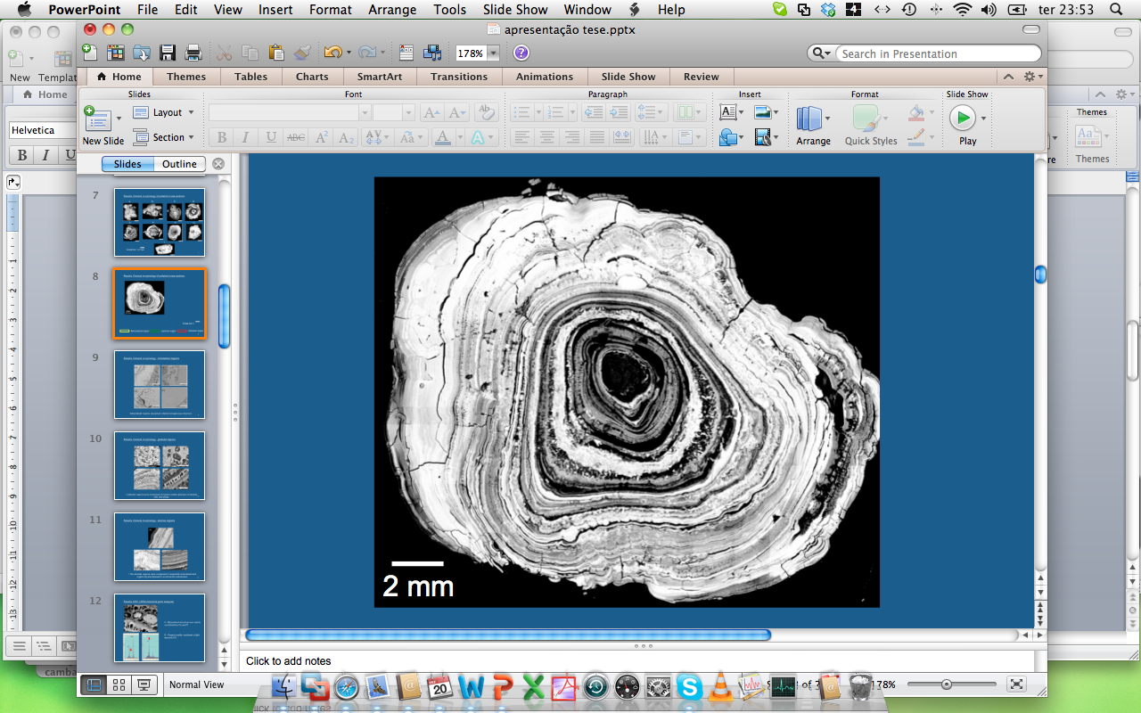

   Figure 1. SEM image of salivary calculus showing chronological layers presenting a laminar or globular morphology (absent core).

   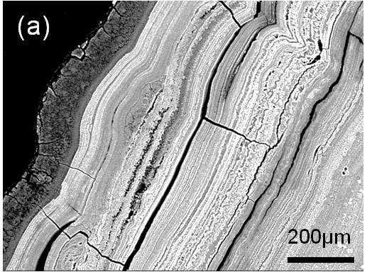 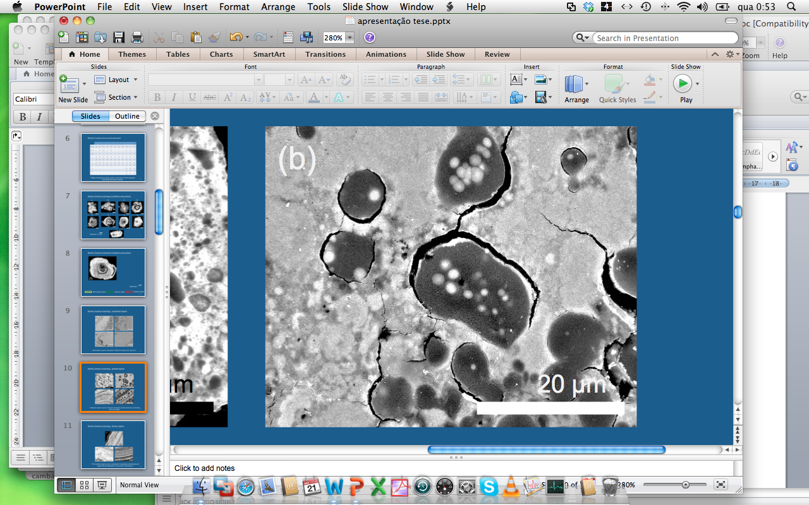

   Figure 2. (a) Detail of a laminar layer. (b) Detail of a globular region.

   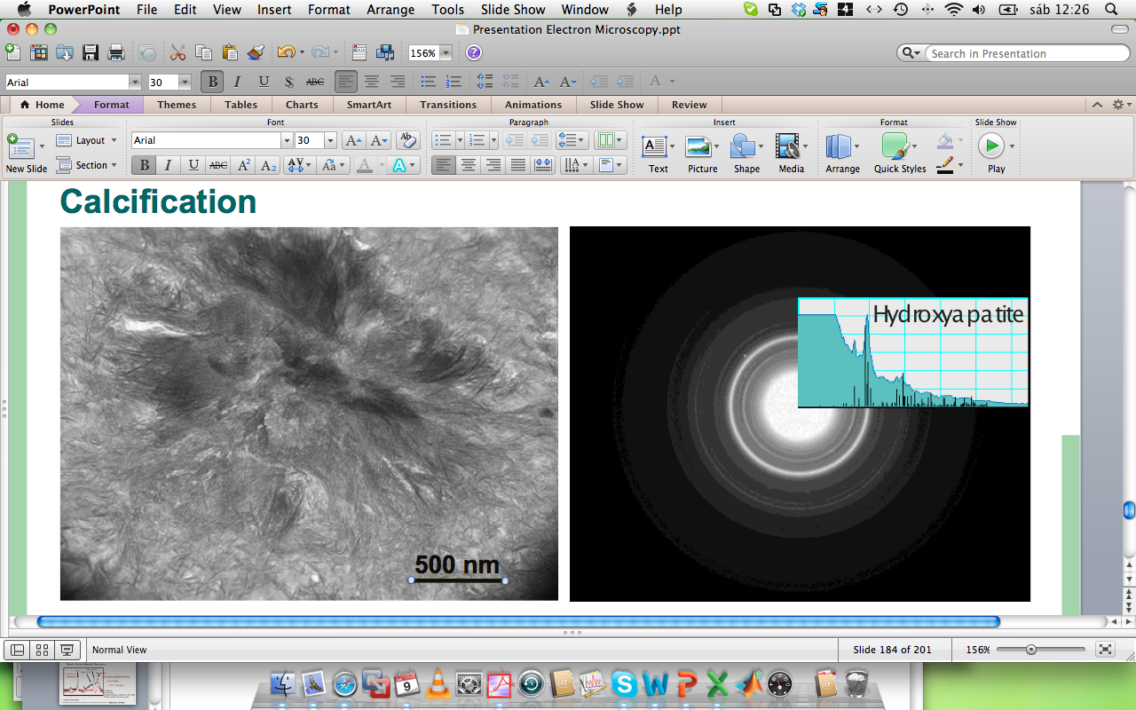

   Figure 3. Bright-field TEM image showing filamentary crystals identified as hydroxyapatite in electron diffraction experiments.

   Financial support received from the Portuguese Science and Technology foundation under the contract PTDC/SAU-ENB/111941/2009.